1. Screen header/title name not display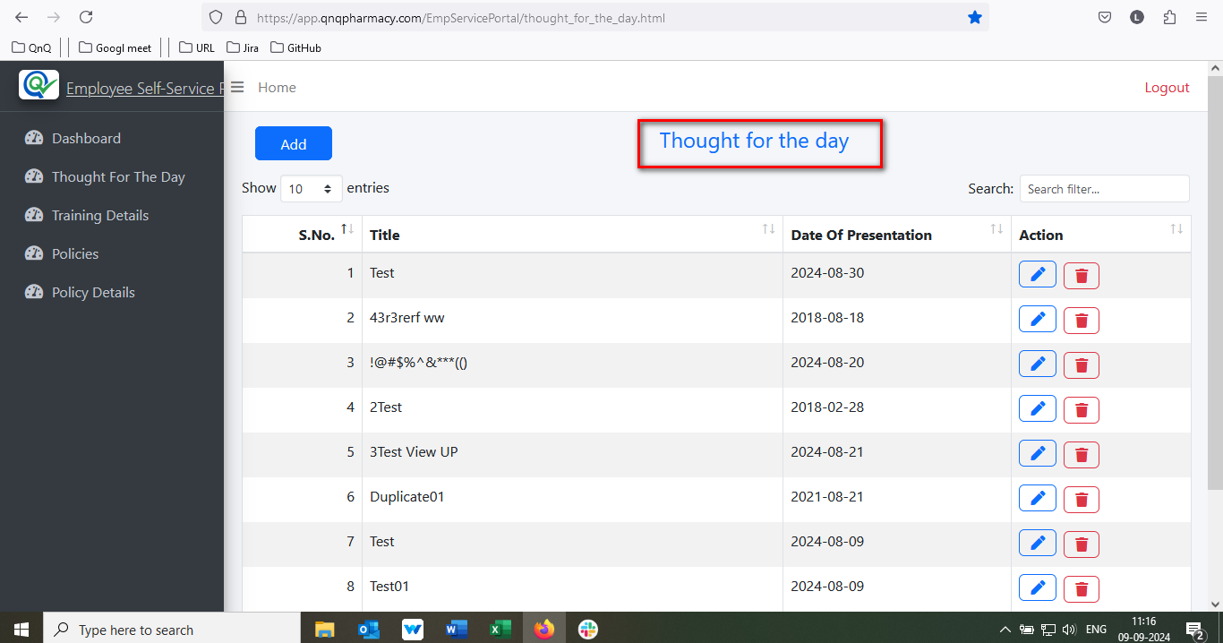//
2. Mismatch menu icon display for Thought for the day//
3. Dot value not getting display for S.No. 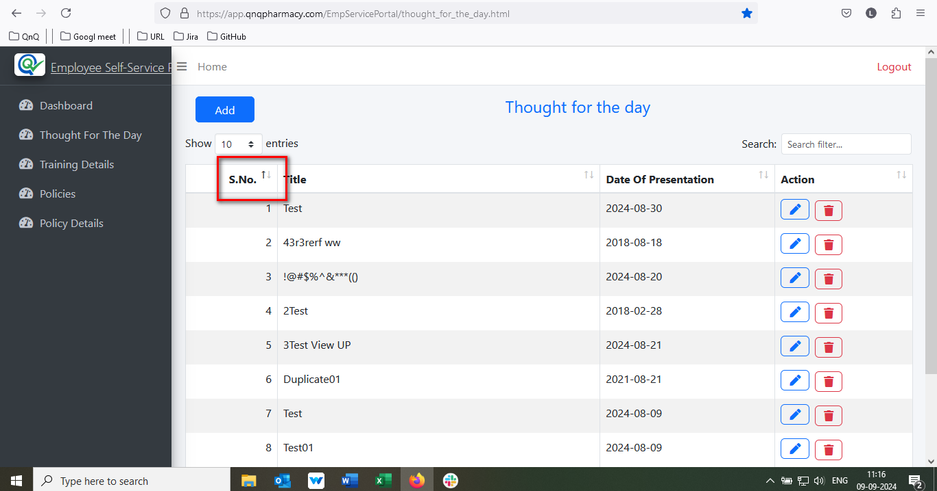//
4. Page Count dropdown not available in Thought for the day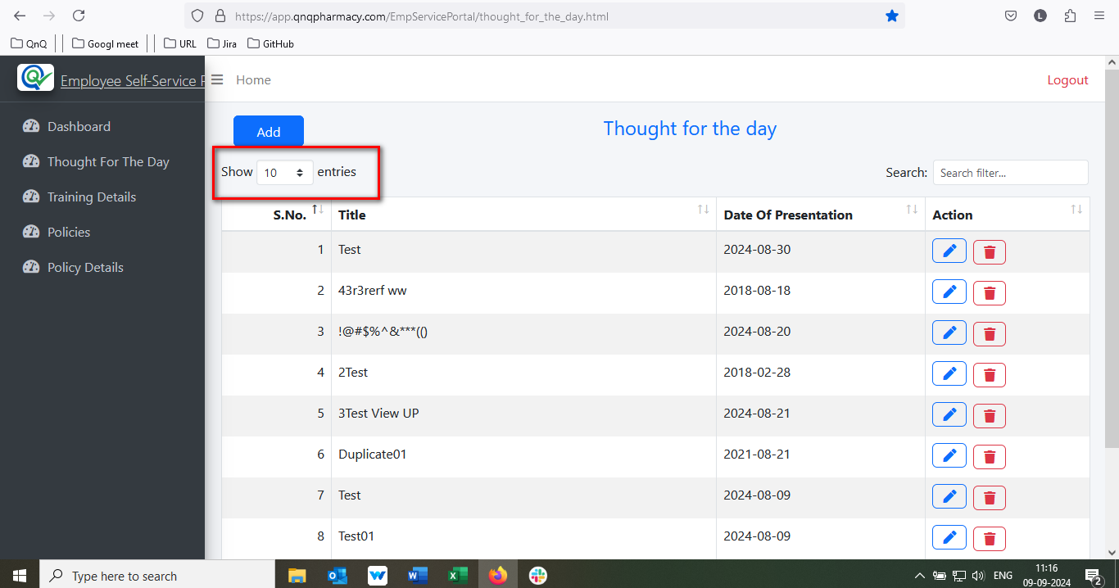//
5. Column header name not display in the middle of the column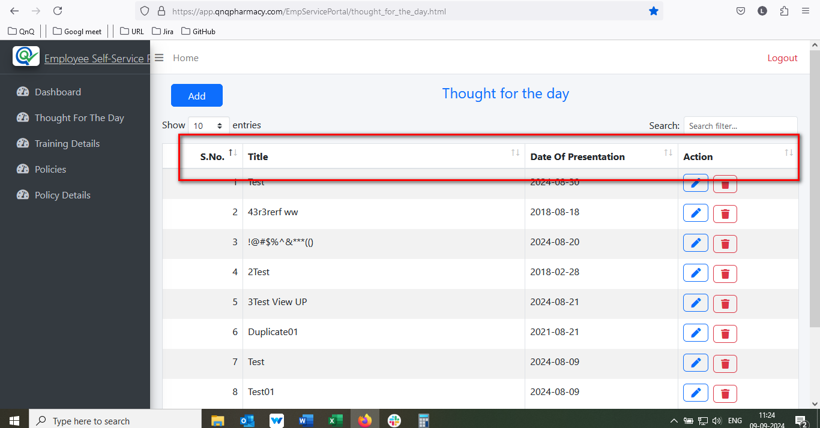//
6. Sort icon not display in the properly//
7. Too many space display between Add new button and list grid column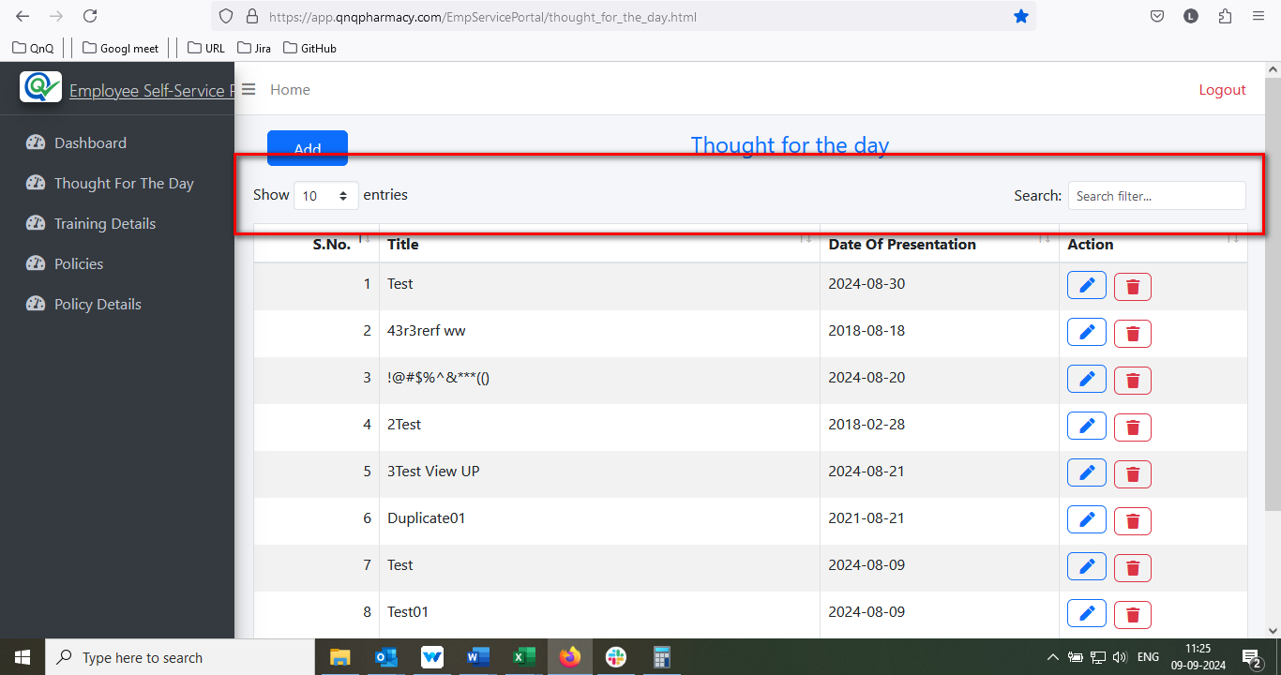//
8. Placeholder or inner text not display in Search filter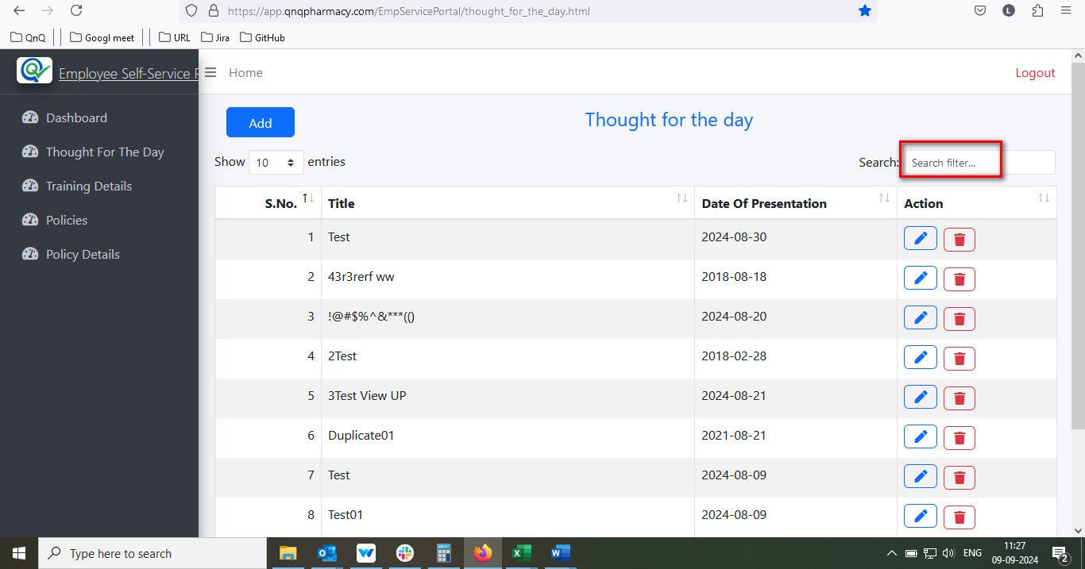//
9. No data available message not display in dashboard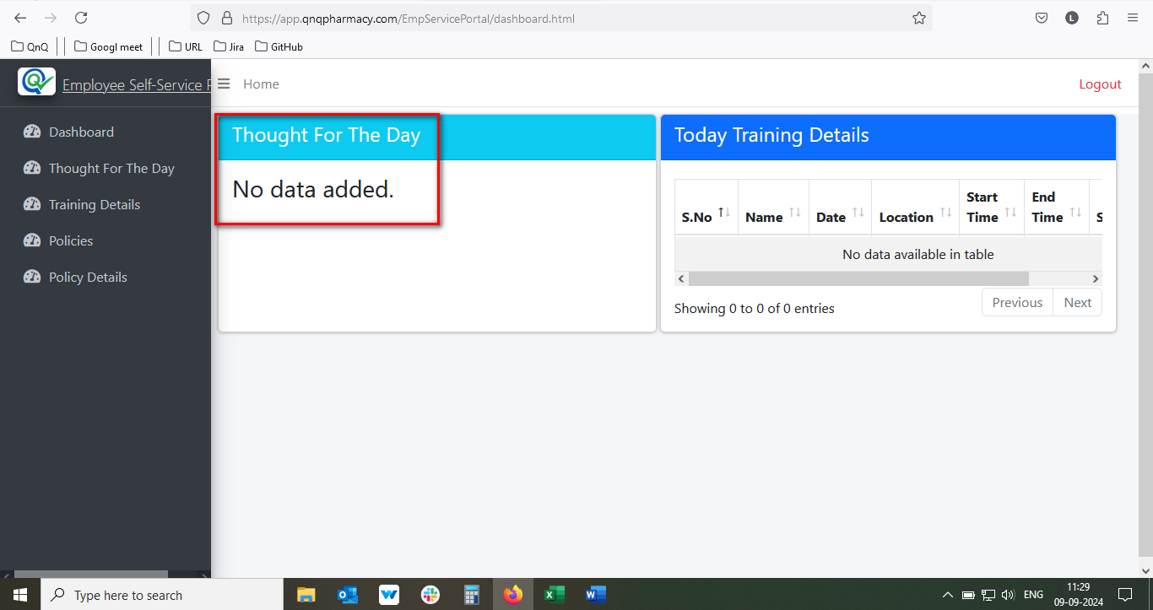//
10. Required error message not getting display while click submit button//
11. Required error message not getting display while skip the field//
12. Title field allow more than 100 characters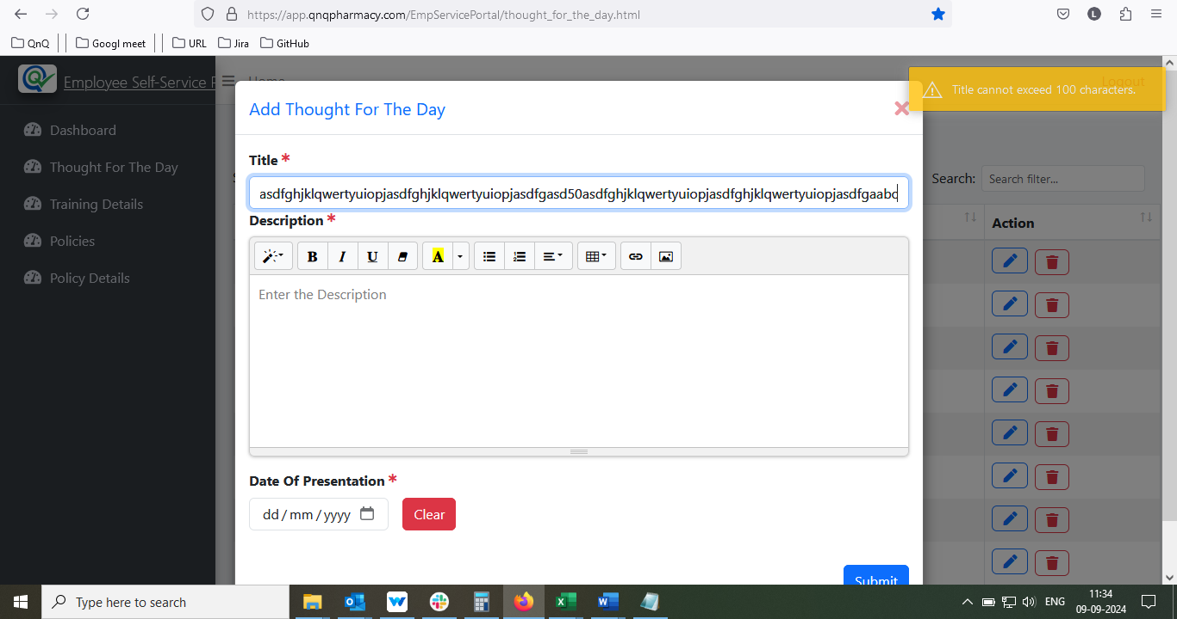//
13. Description field allow more than 500 characters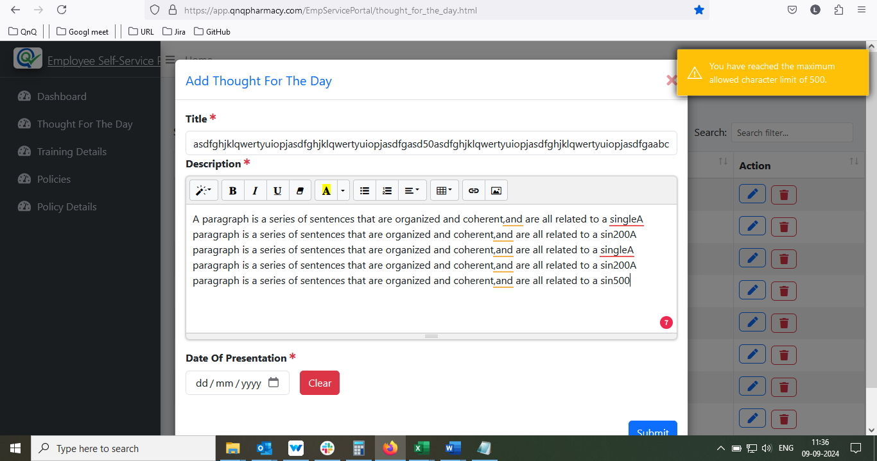//
14. Date Of Presentation field not allow to perform copy & paste//
15. Title field allow special characters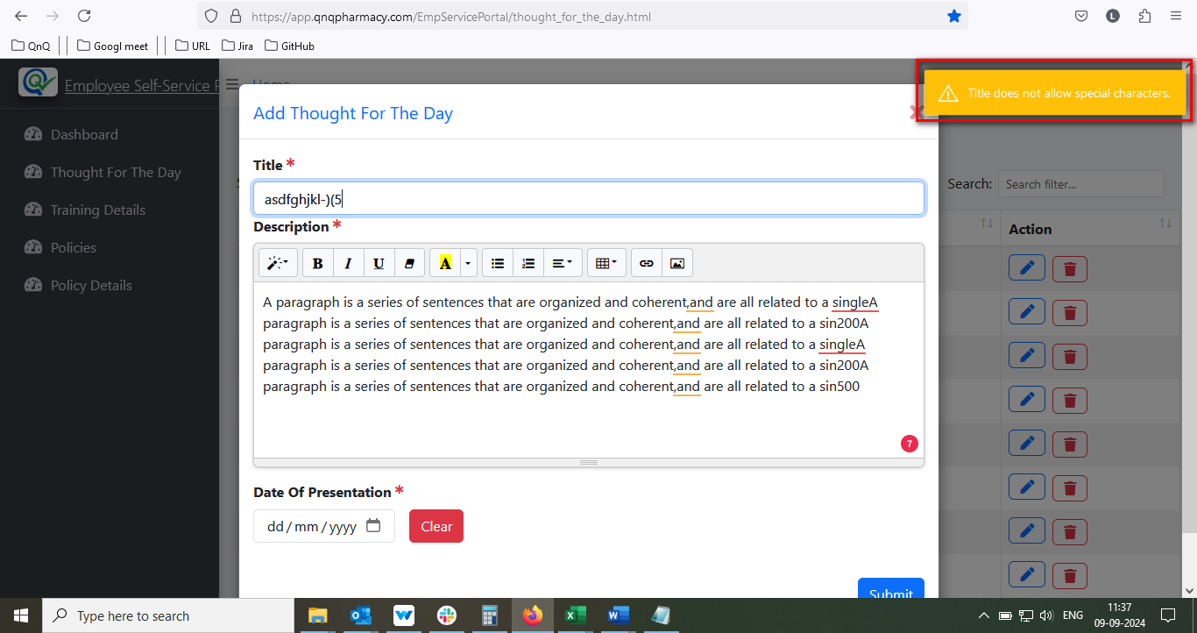//
16. Thought for the day column display improper alignment while give maximum value in Description field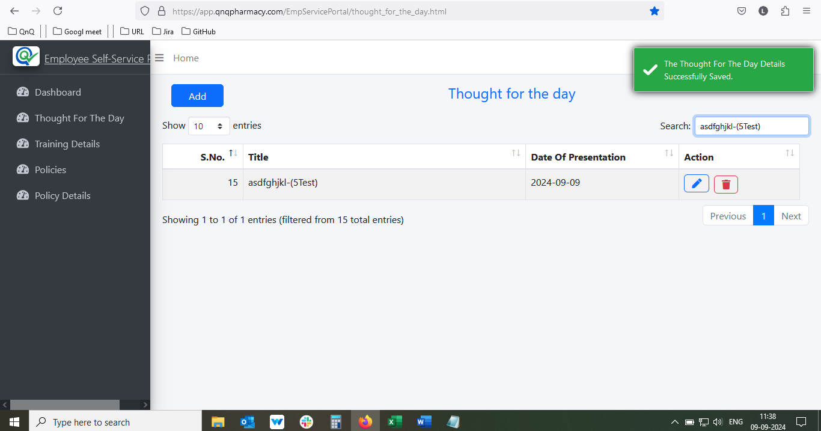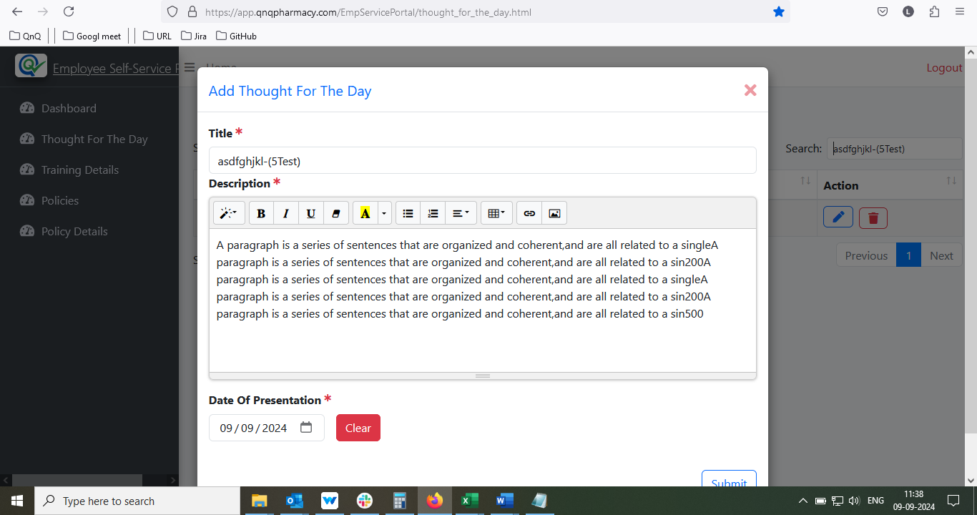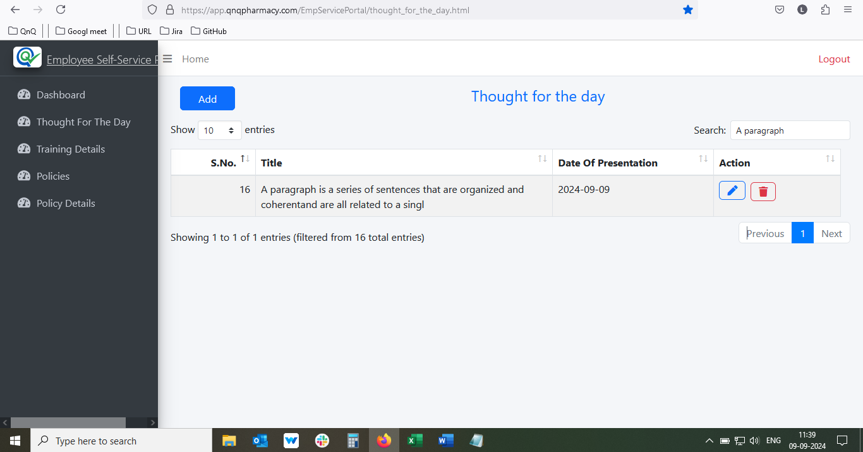//
17. Placeholder or inner text not display in Add Thought For The Day pop up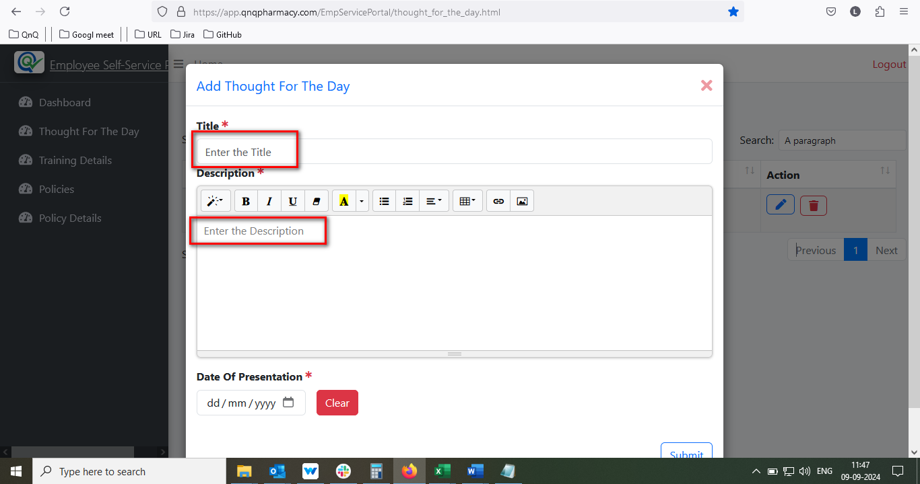//
18. Description field display resized alignment, while click the add new button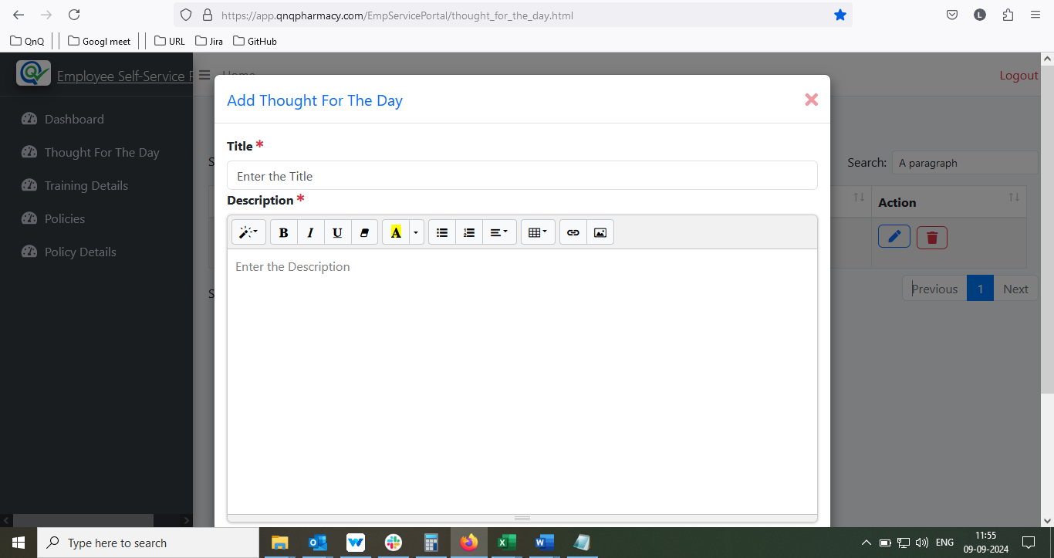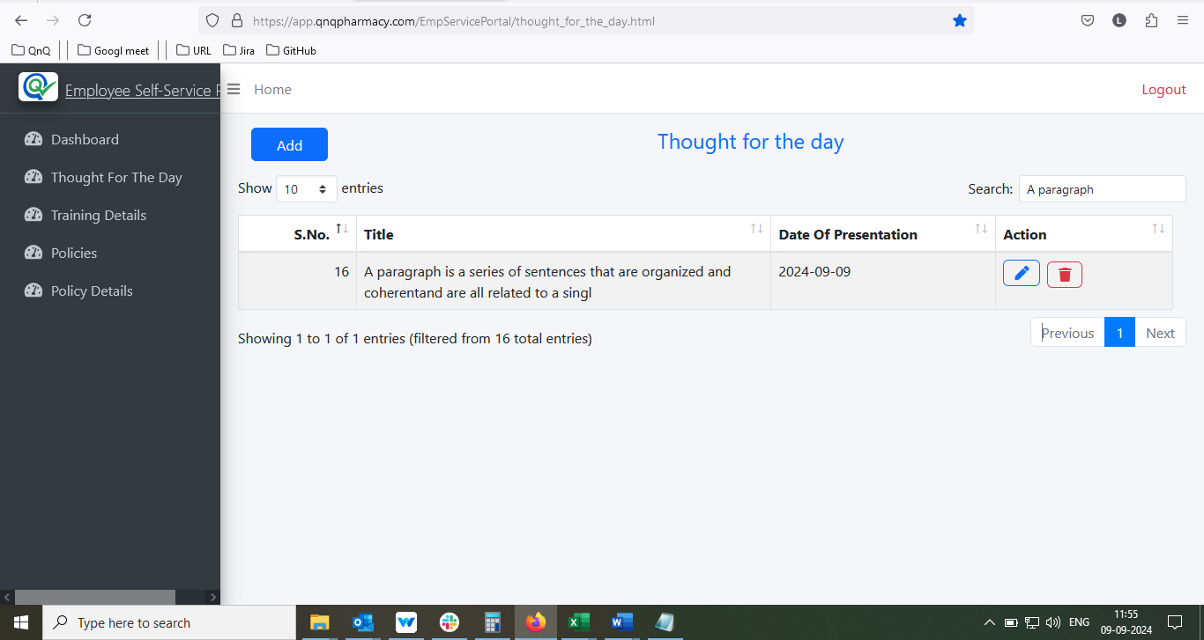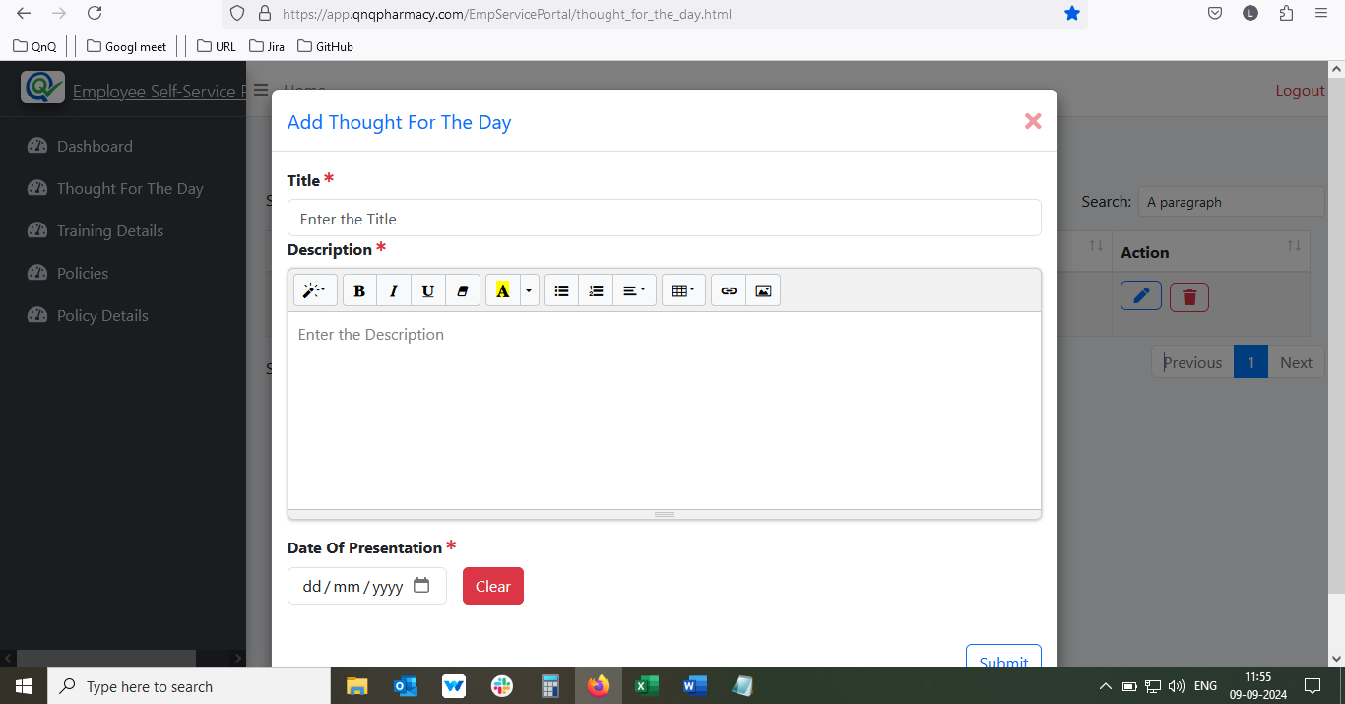//
19. Red Colour highlight indication not getting clear while give the value in same field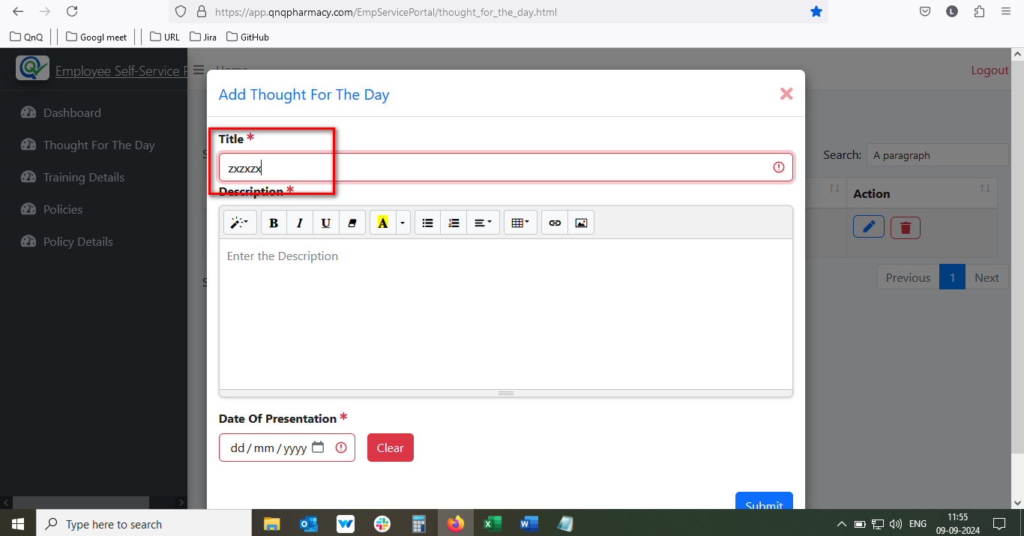//
20. Success message display mismatch content //
21. Update message display mismatch content//
22. Delete message display mismatch content //
23. Mismatch title display in delete pop up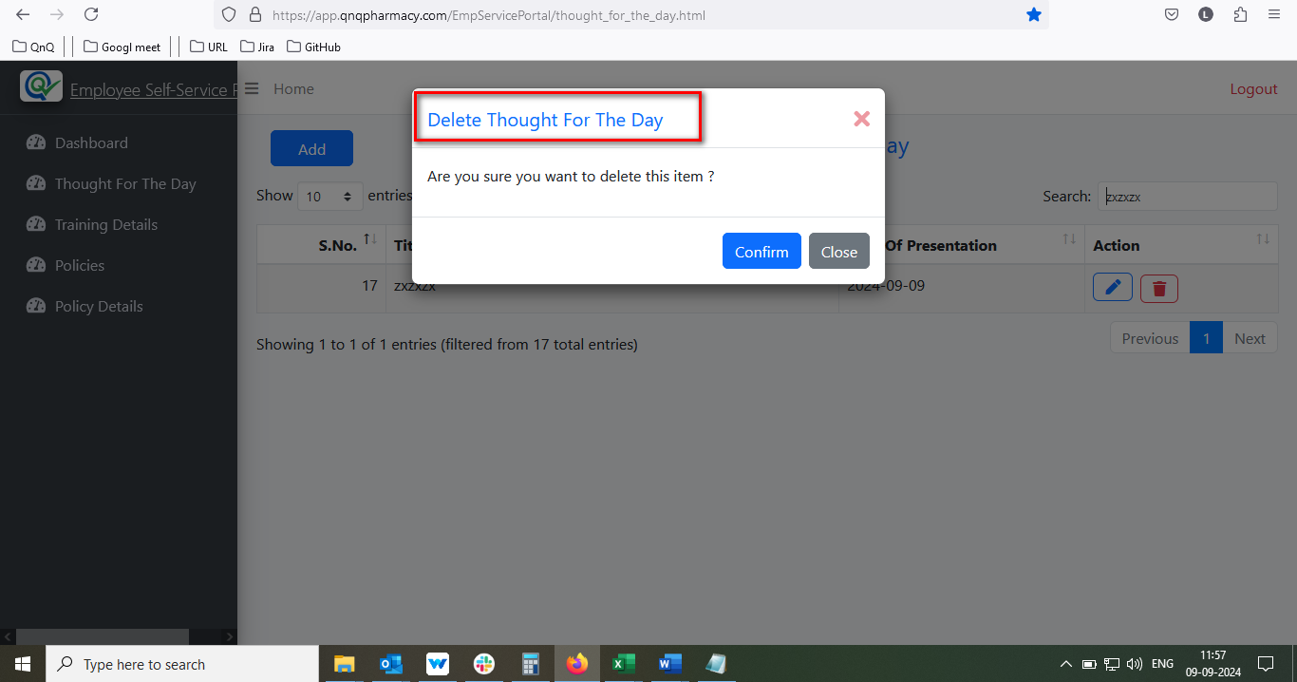//
24. Unwanted content display while click delete icon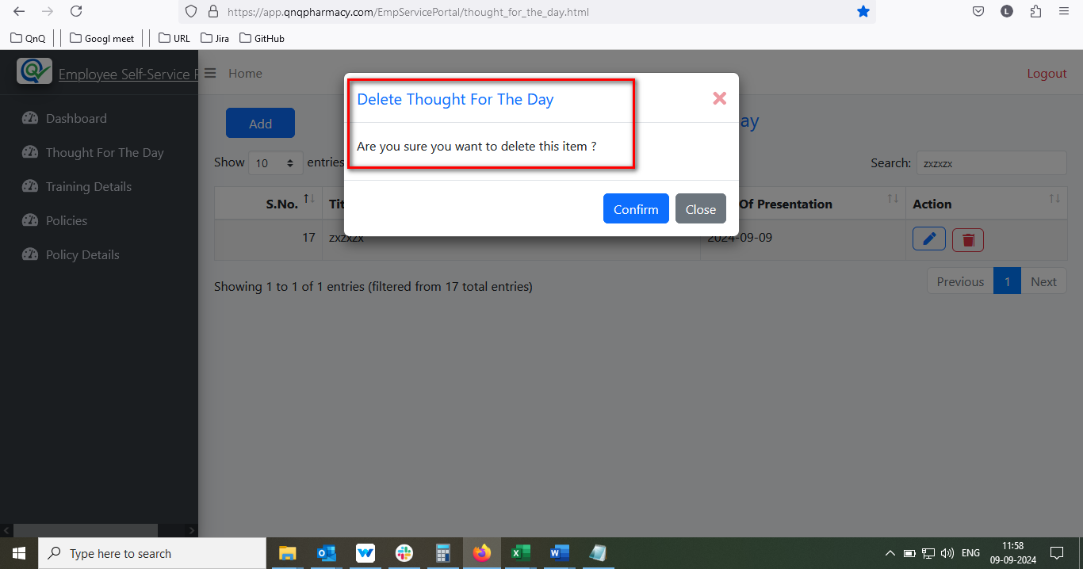//
25. Existing value display while click add new button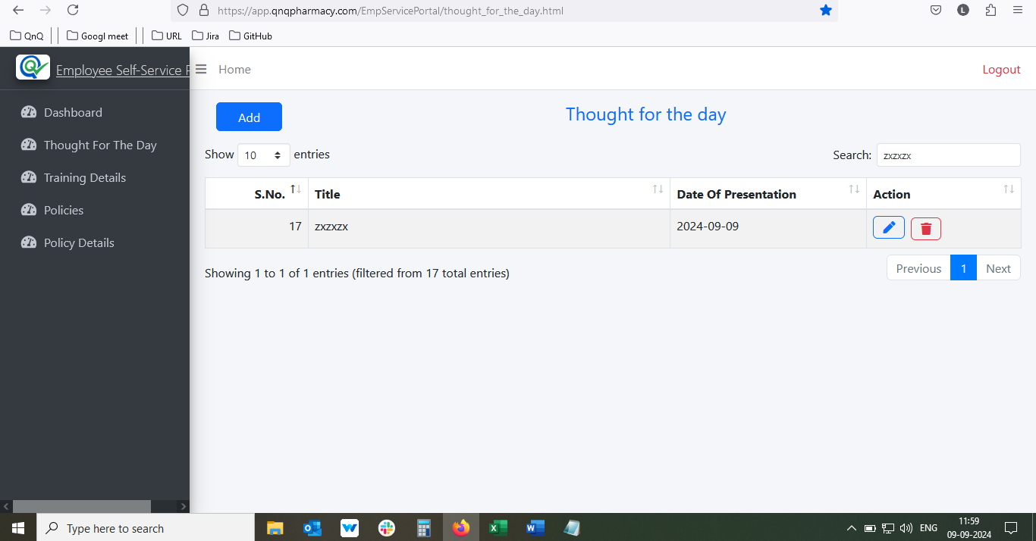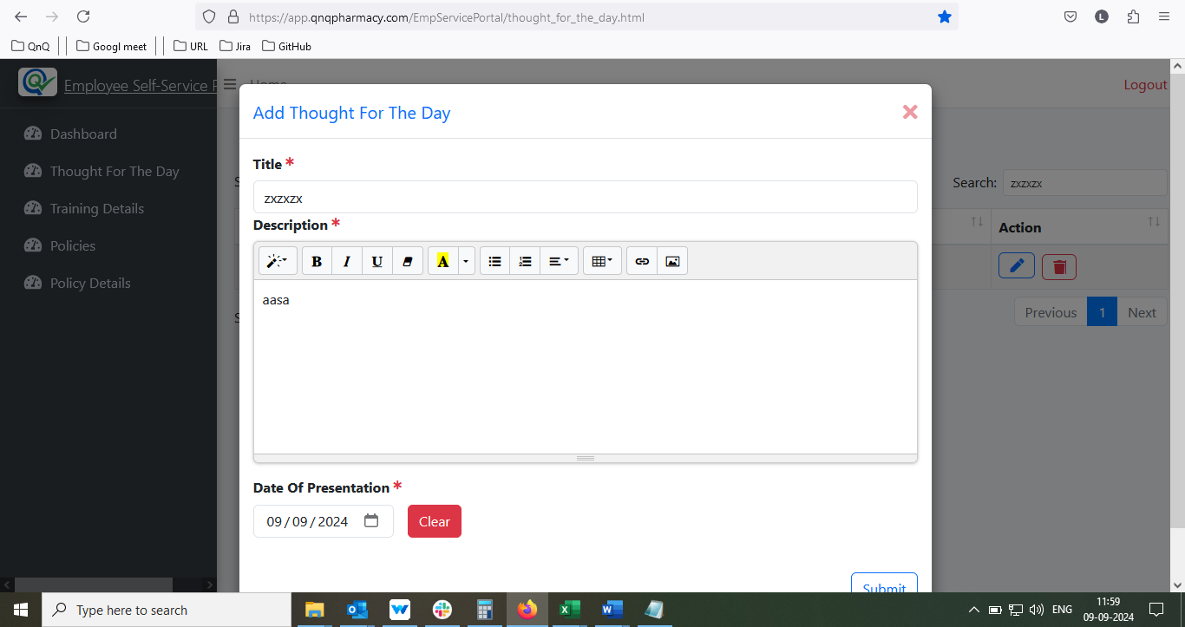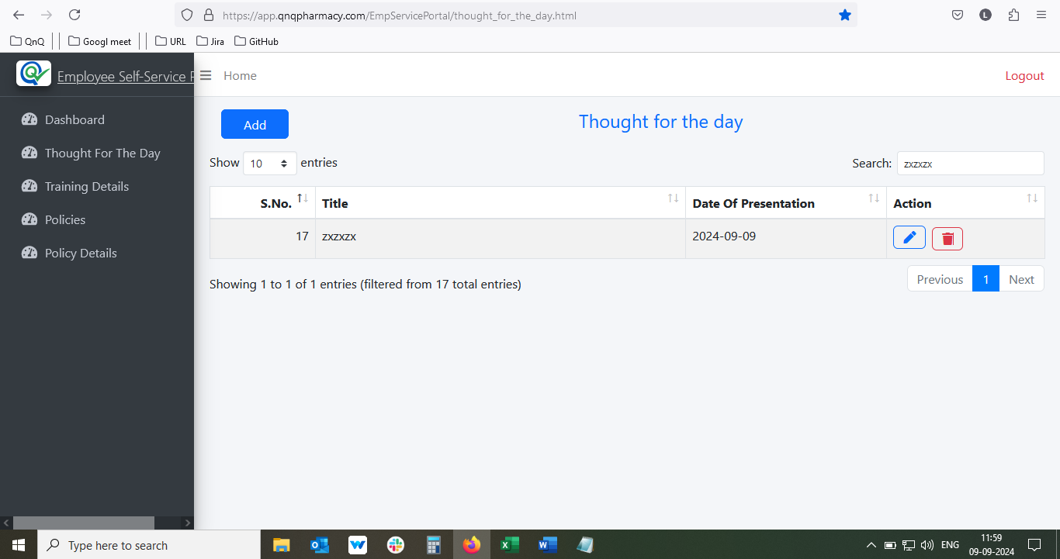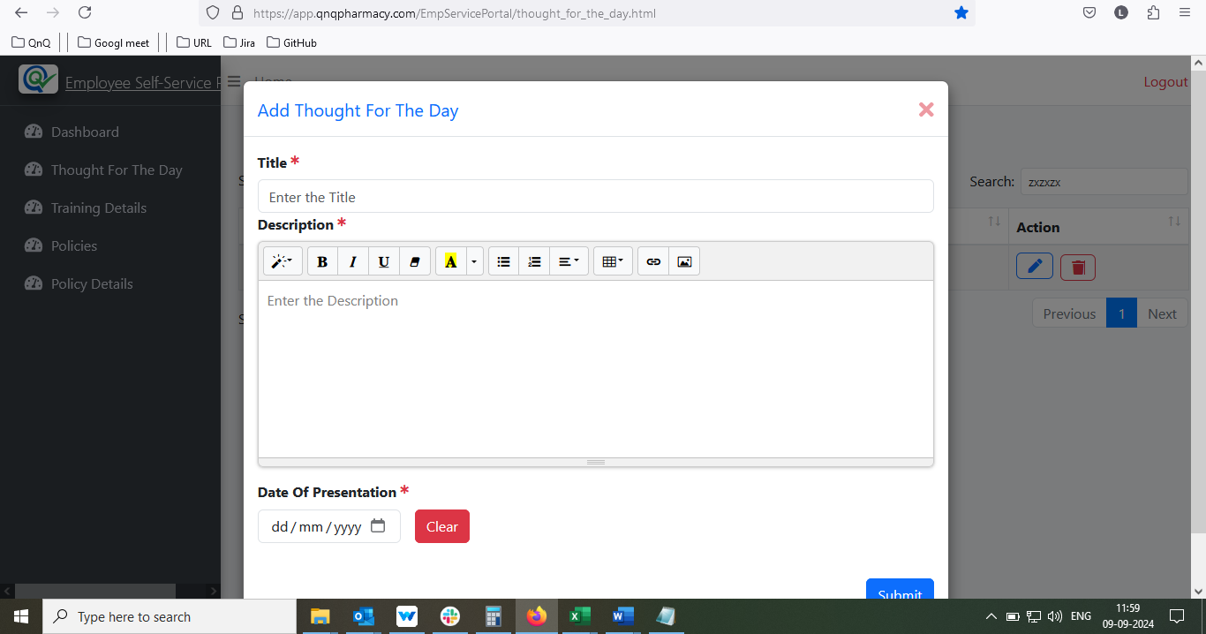//
26. Updated success message display without updates any value//
27. Given value not getting clear while reopen the record without save the record when 1 st time open the record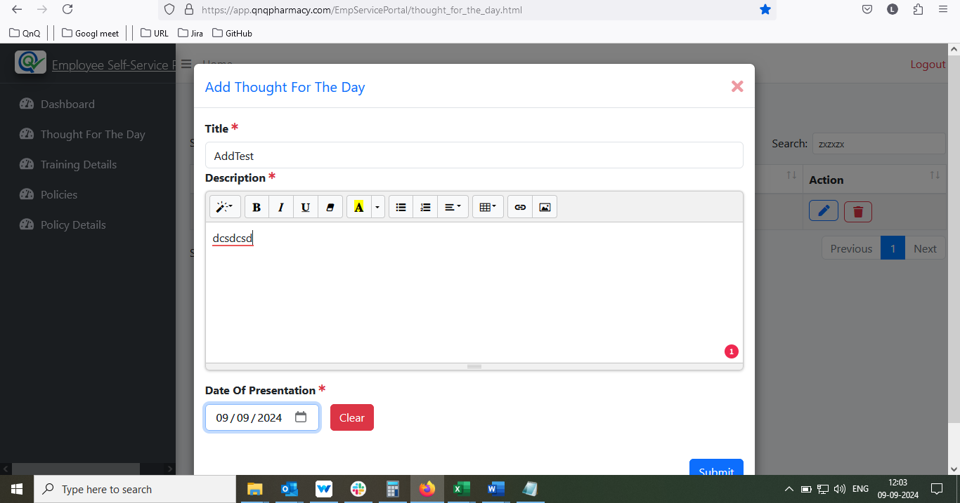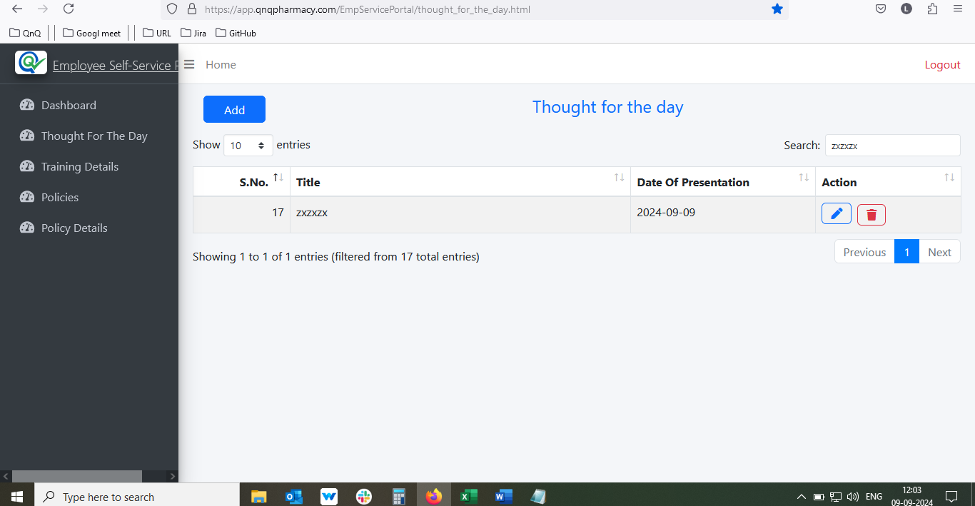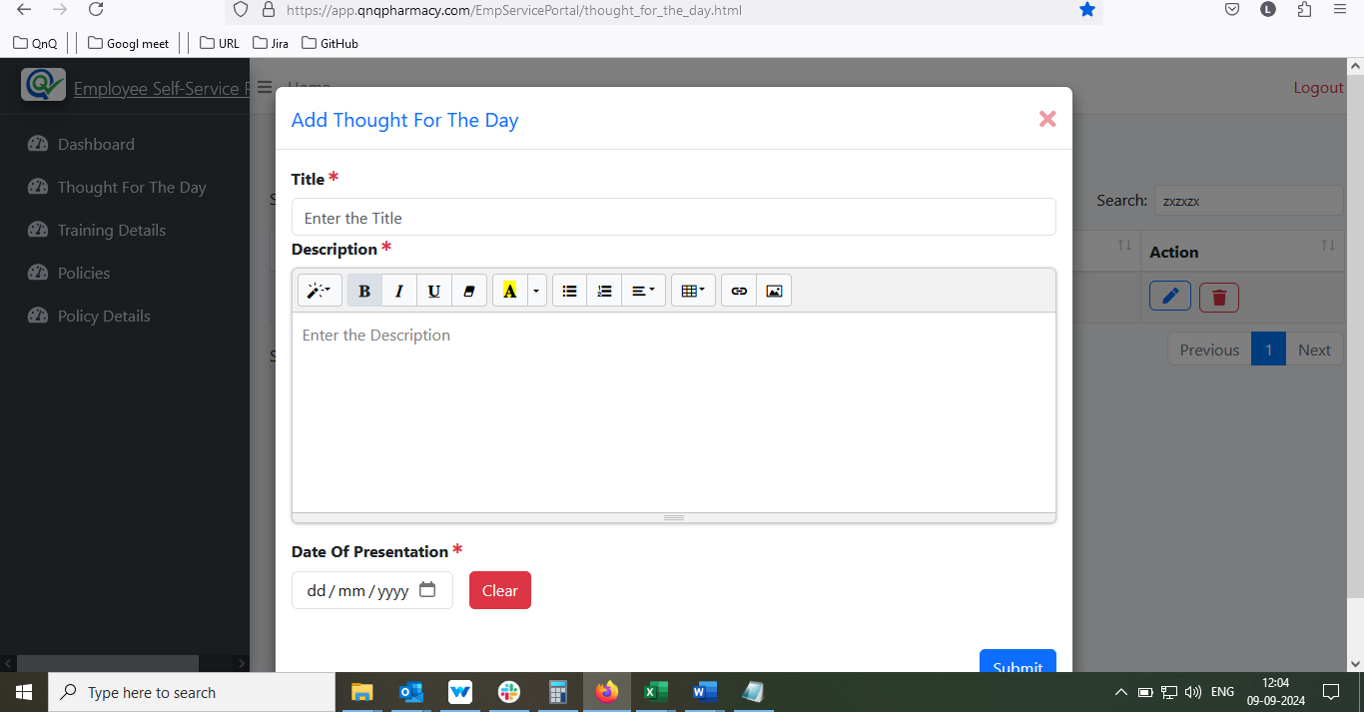//
28. Unable to create or update any record, while close the Insert Link/Image/video pop up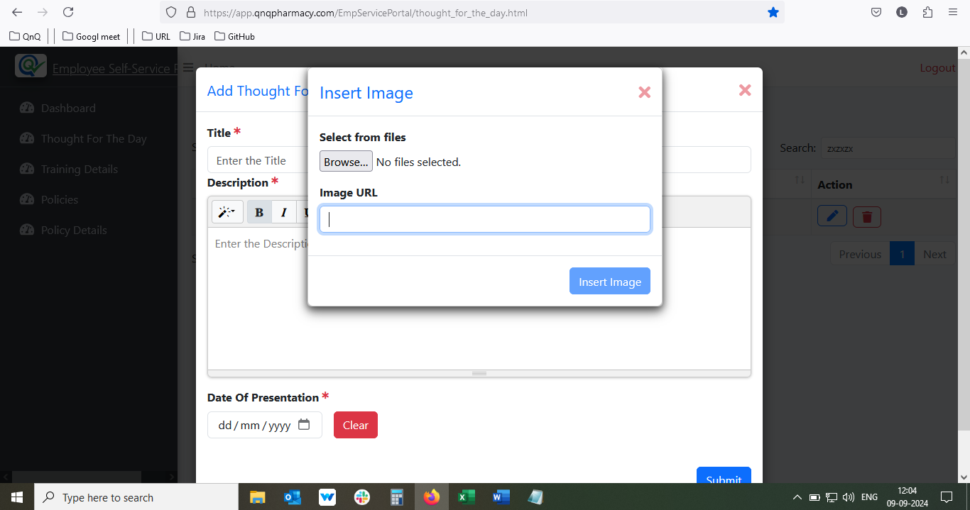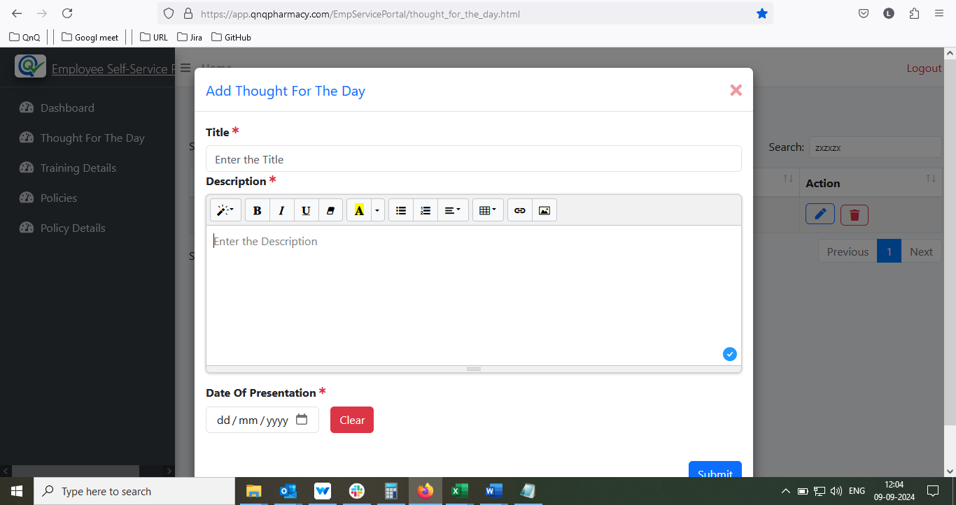//
29. Mismatch tool tip display for screen view mode//
30. New URL not getting load same page when uncheck the open in new window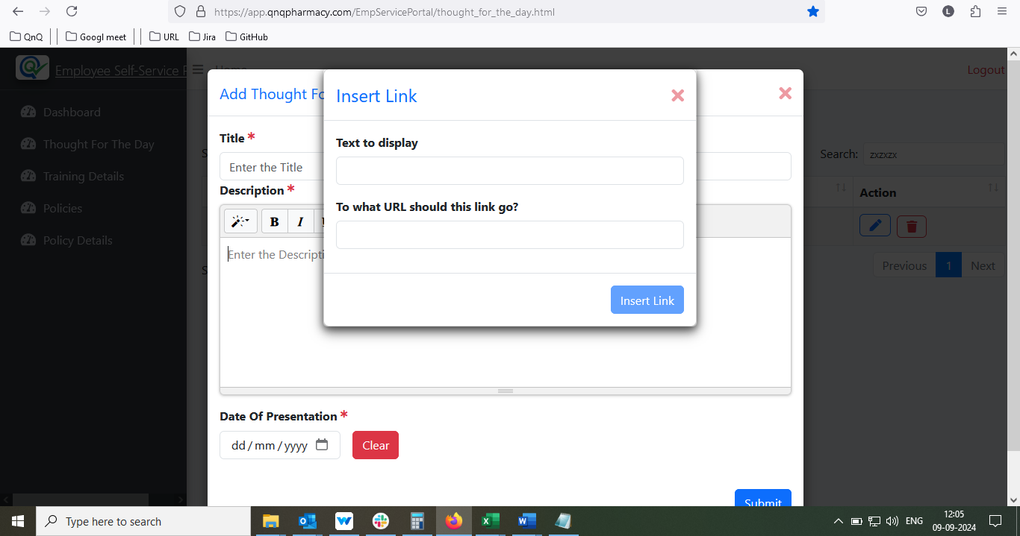//
31. Given URL not getting clear while unlink the URL//
32. System not display any error message while give less than current date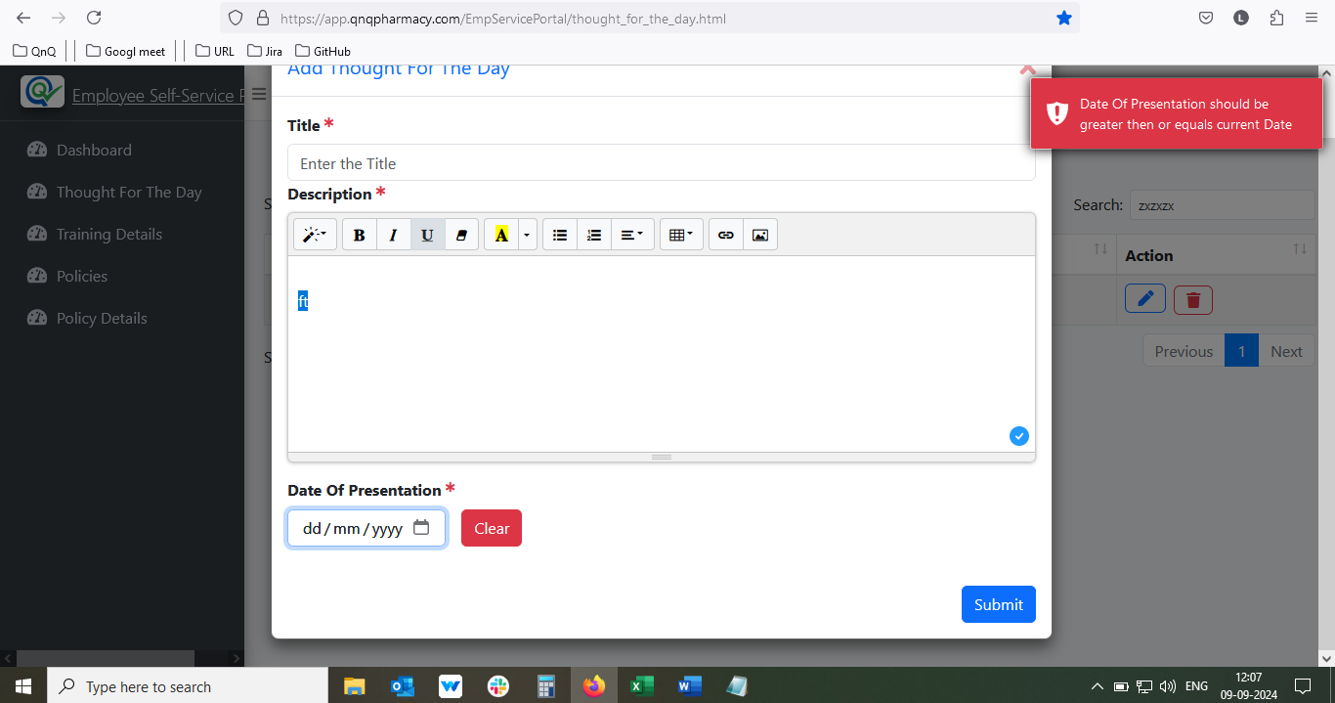//
33. Callender pop up getting close while click the clear button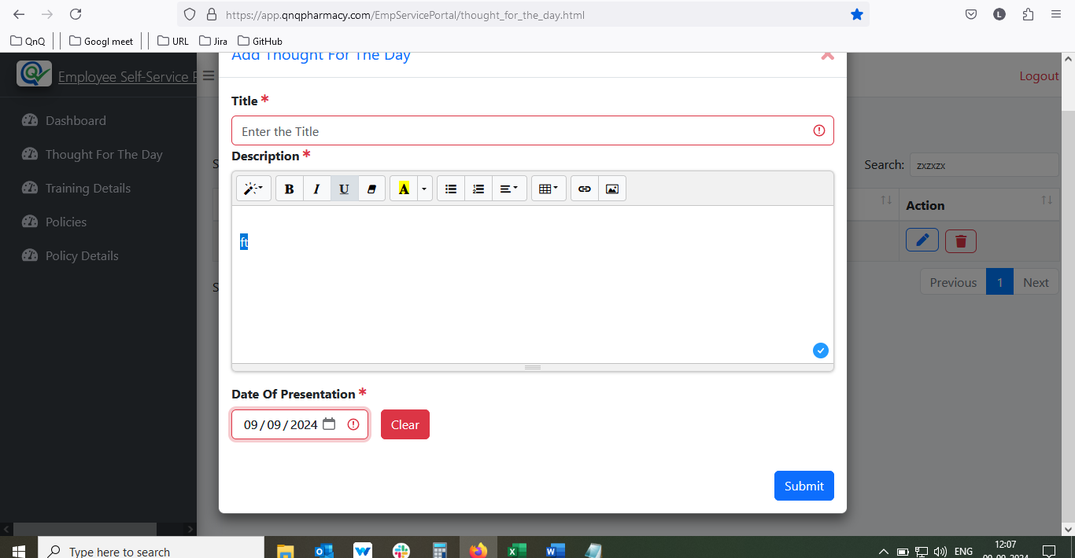 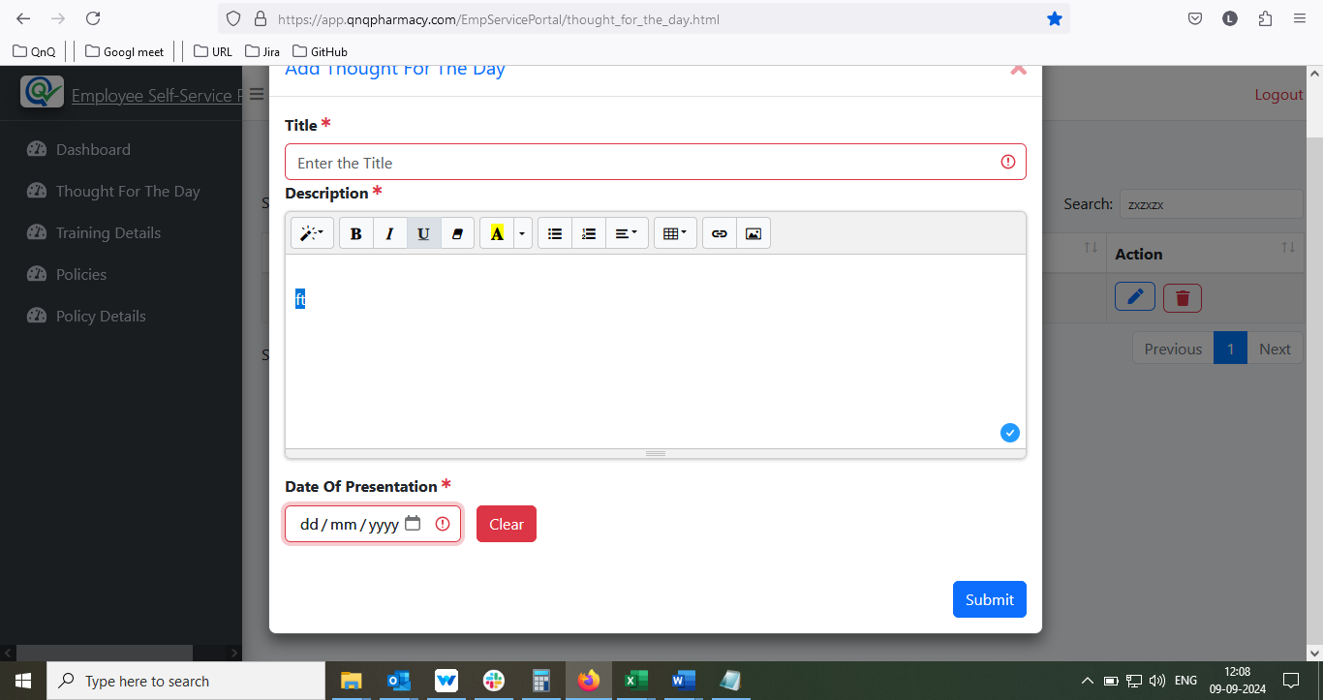//
34. Record saves with only space value //
35. UI getting collapse while click code view icon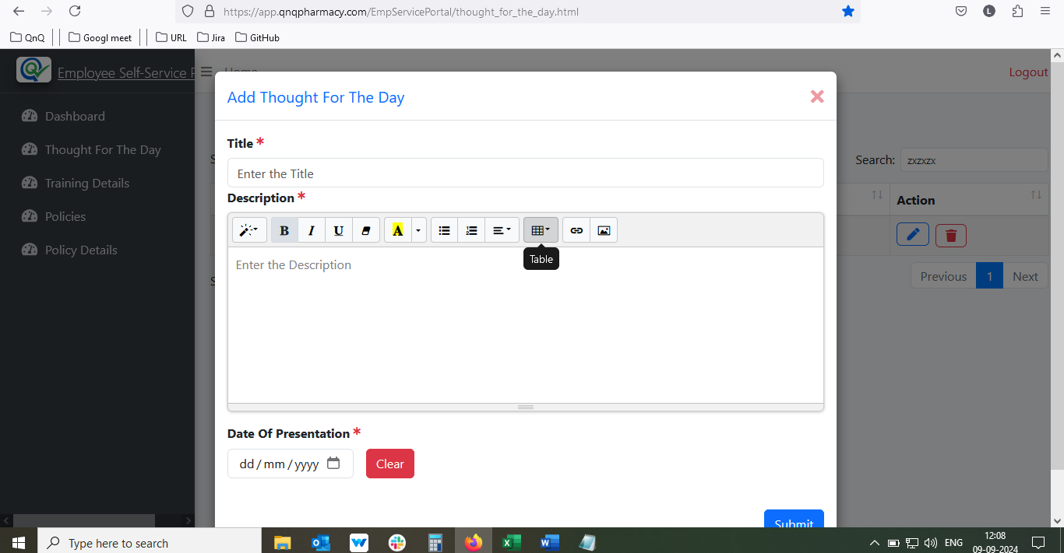 //
36. Red Colour highlight indication not getting clear while click add new button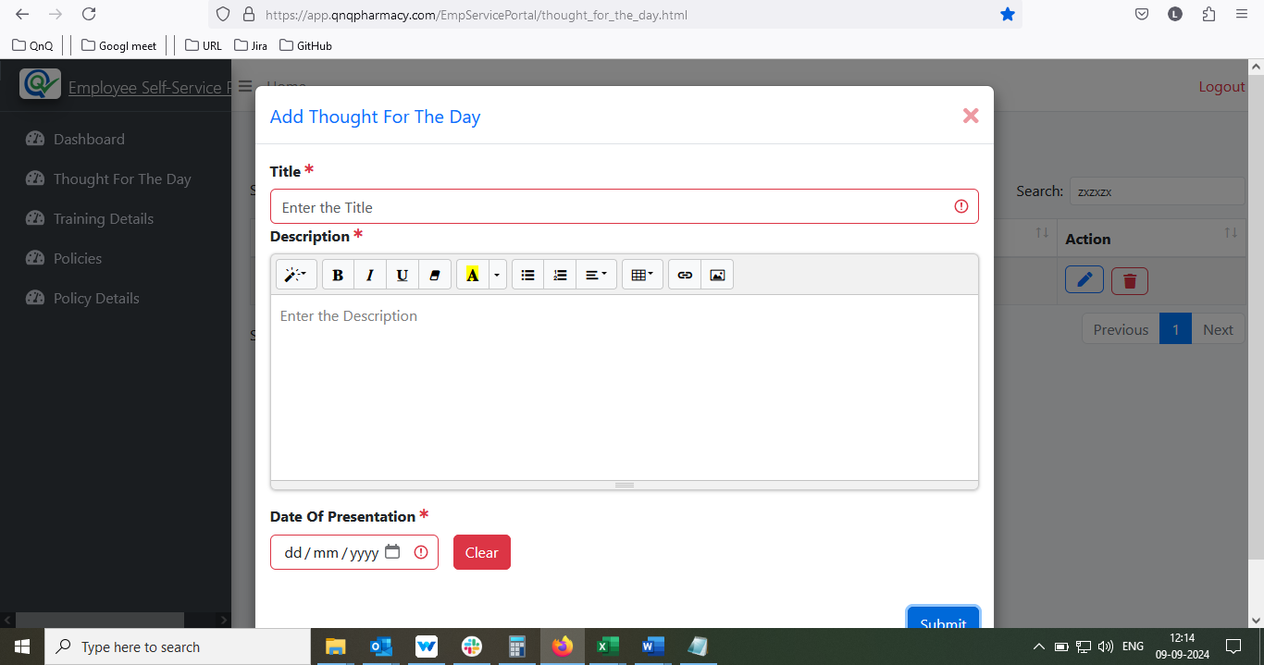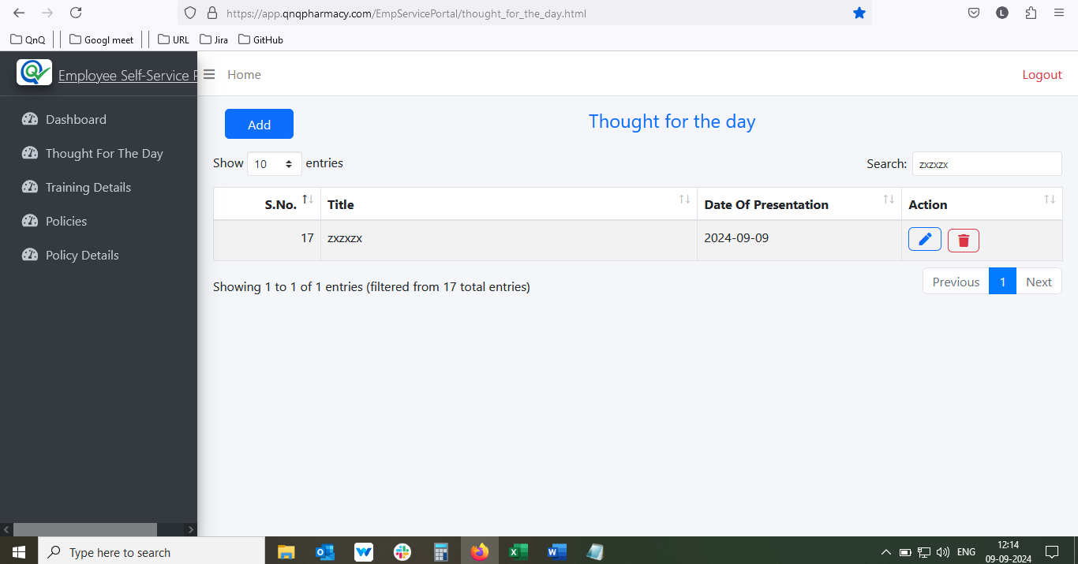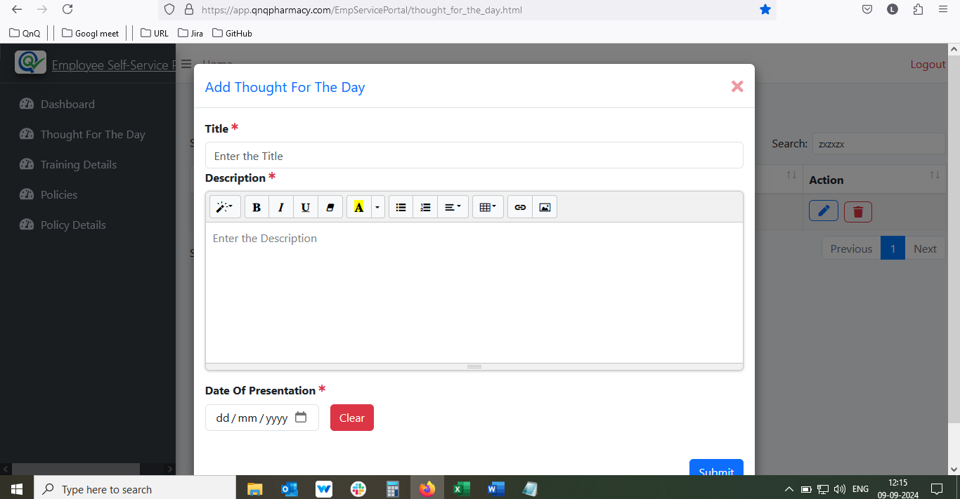//
37. Mismatch content display for the Delete confirmation pop up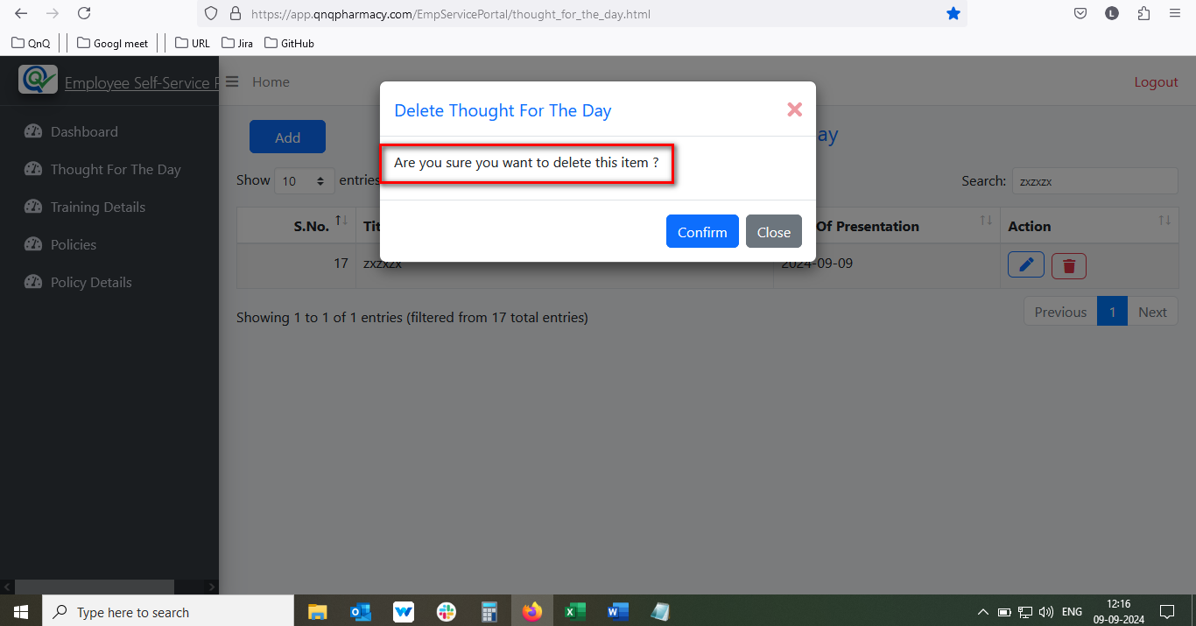 //
38. Pop up title display as normal label name, it’s not look like title name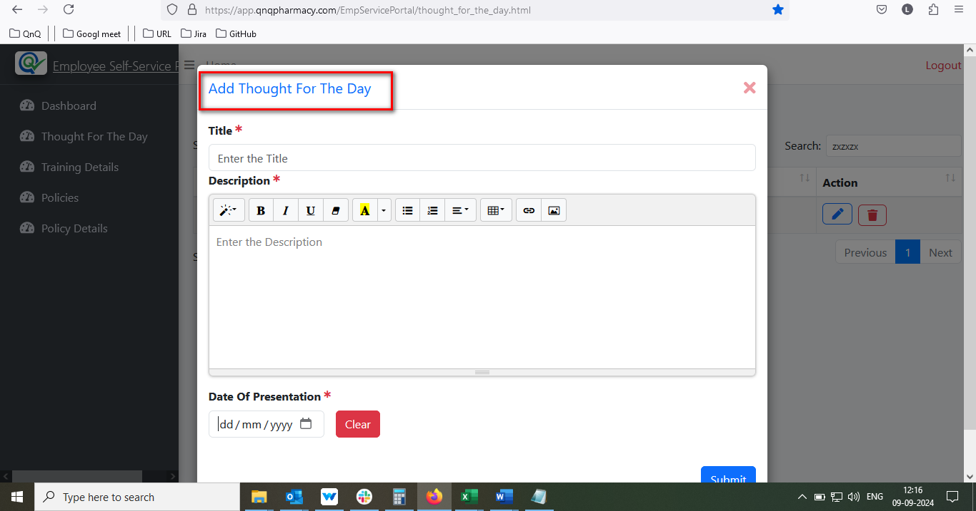//
39. Unwanted icon displays in description field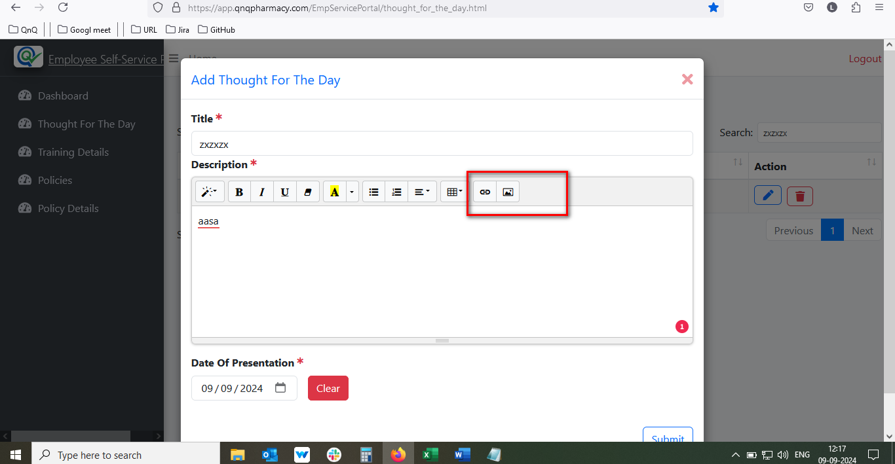//
40. Created new record not display in list grid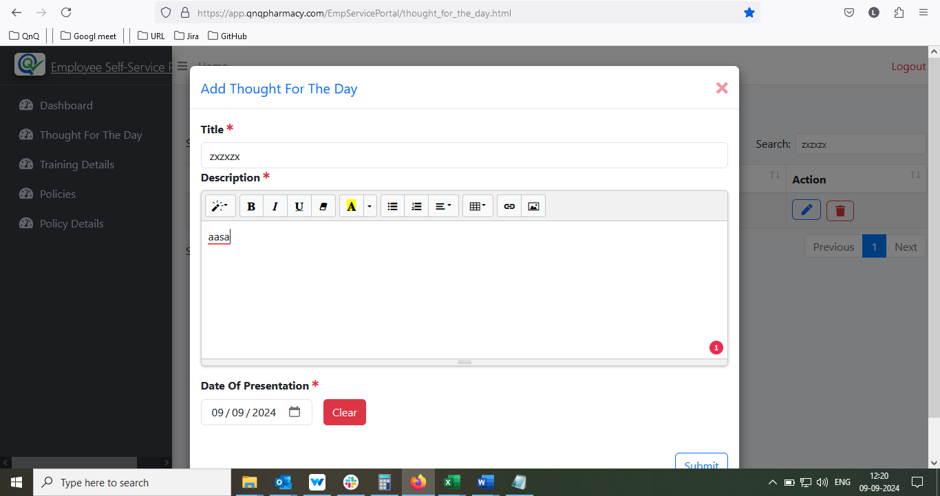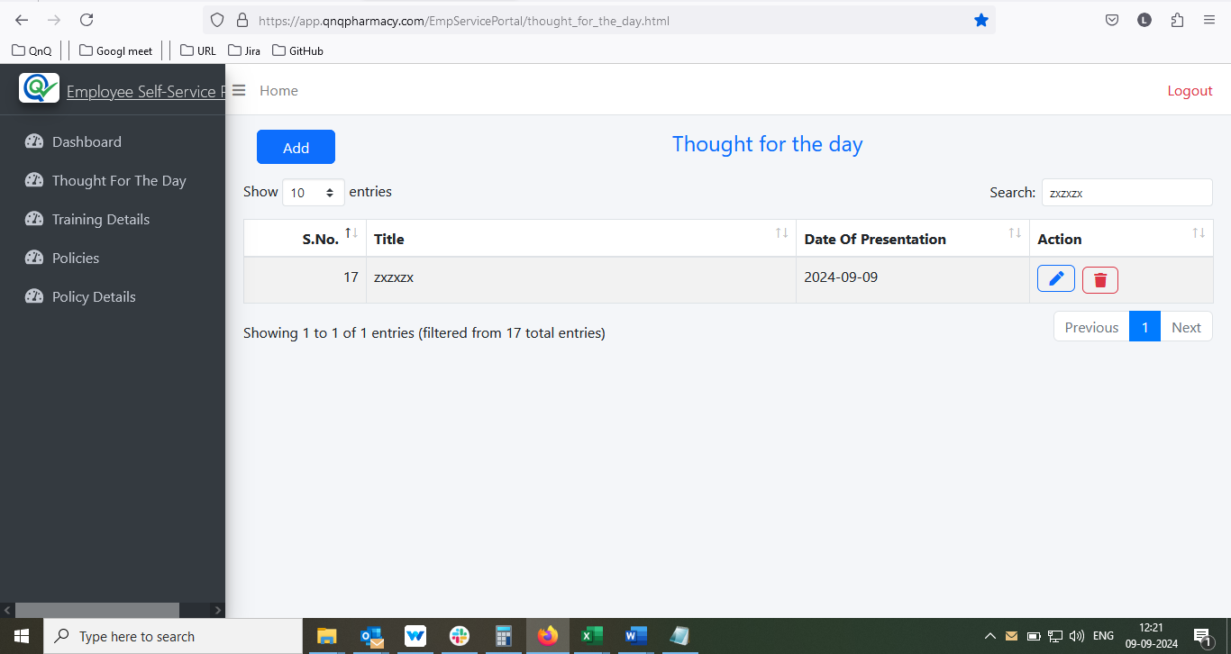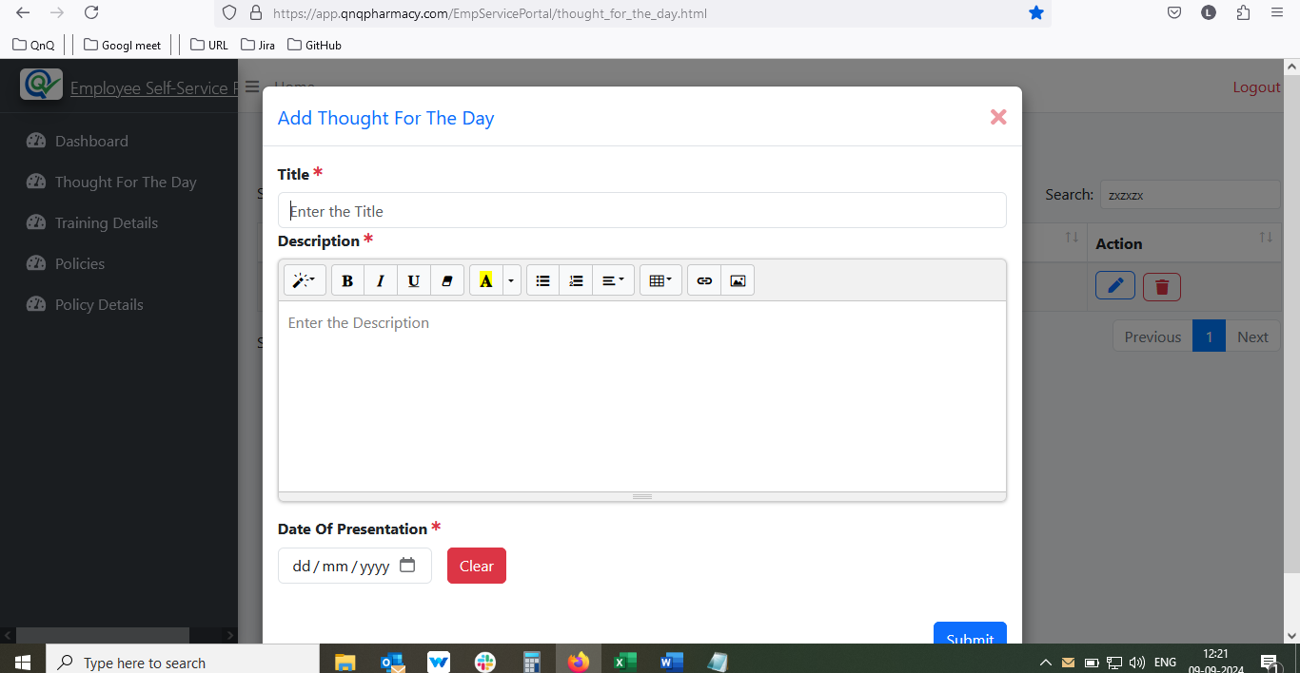//
41. System allows to create the duplicate records//
42. Created success message display but the created record not display in the list grid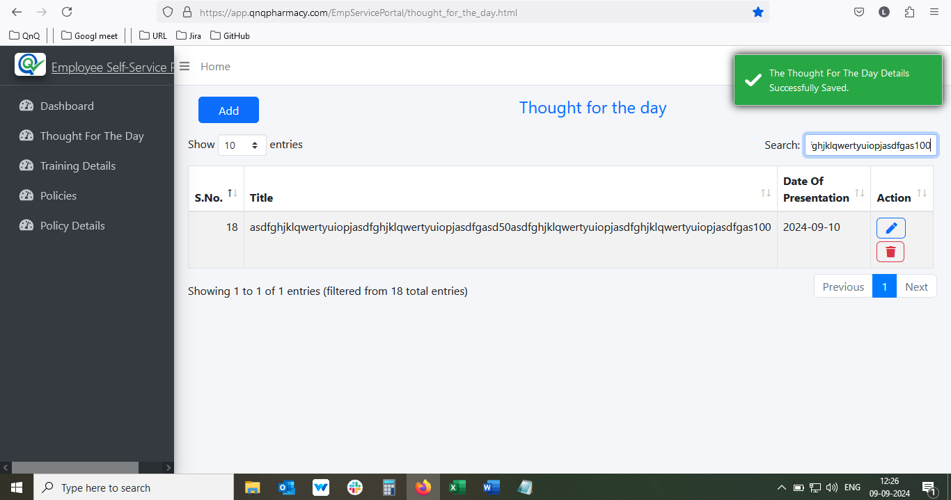//
43. Link/Image/video pop up getting close without click close icon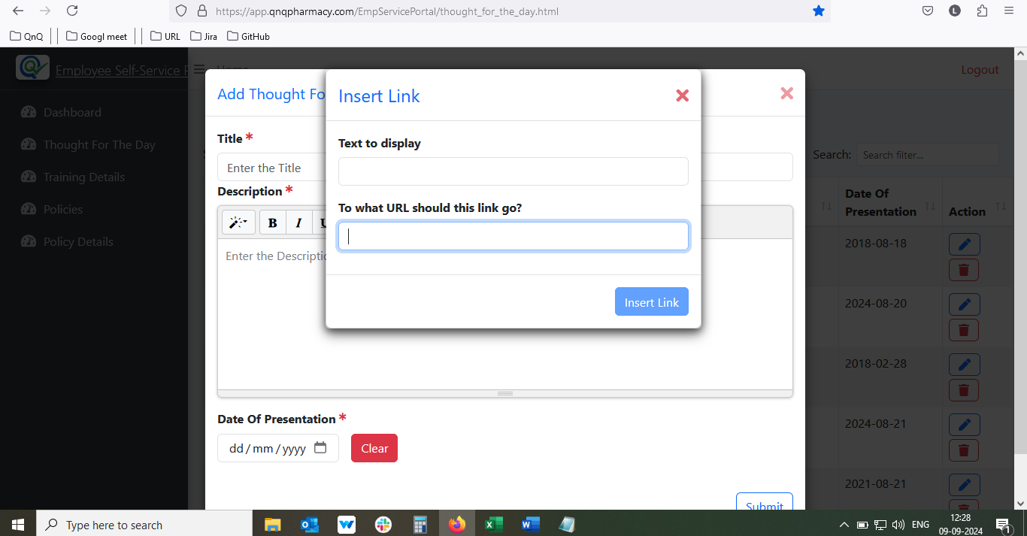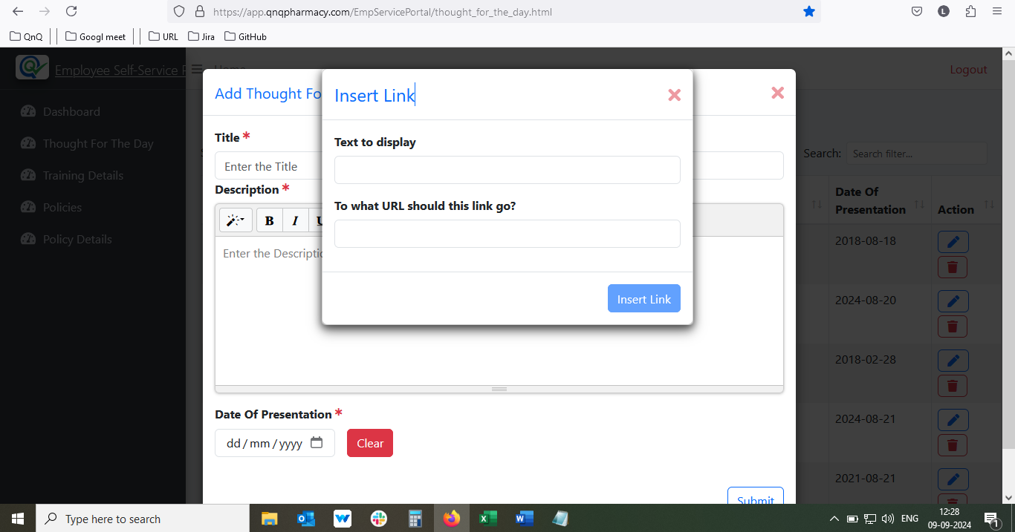//
44. Tool tip not display for Close icon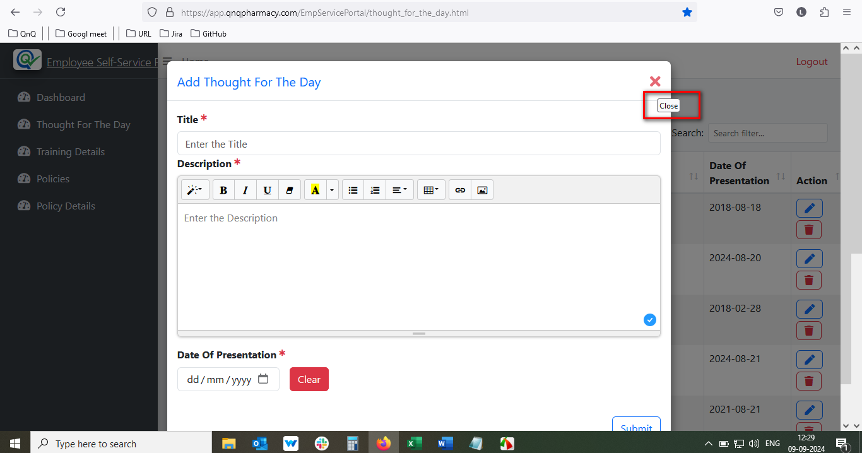//
45. Red Colour highlight indication display clear while click edit icon